VIA USB 2.0
Host Controller

Driver Installation Guide

Revision 2.1

July 31, 2026
Copyright Notice:
Copyright © 2002 and 2003 VIA Technologies Incorporated. All Rights Reserved. No part of this document may be reproduced, transmitted, transcribed, stored in a retrieval system, or translated into any language, in any form or by any means, electronic, mechanical, magnetic, optical, chemical, manual or otherwise without the prior written permission of VIA Technologies Incorporated. The material in this document is for information only and is subject to change without notice. VIA Technologies Incorporated reserves the right to make changes in the product design without reservation and without notice to its users.
VIA USB 2.0 Host Controller, VT6202, VT6212 and VT8235 may only be used to identify products of VIA Technologies.

is a registered trademark of VIA Technologies, Incorporated.
Windows XPTM, Windows 2000TM, Windows METM and Windows 98SETM are registered trademarks of Microsoft Corp.
PCITM is a registered trademark of the PCI Special Interest Group.
All trademarks are the properties of their respective owners.

Disclaimer Notice:
No license is granted, implied or otherwise, under any patent or patent rights of VIA Technologies. VIA Technologies makes no warranties, implied or otherwise, in regard to this document and to the products described in this document. The information provided by this document is believed to be accurate and reliable to the publication date of this document. However, VIA Technologies assume no responsibility for any errors in this document. Furthermore, VIA Technologies assume no responsibility for the use or misuse of the information in this document and for any patent infringements that may arise from the use of this document. The information and product specifications within this document are subject to change at any time, without notice and without obligation to notify any person of such change.

Offices:
USA Office: Taipei Office:
940 Mission Court 8th Floor, No. 533
Fremont, CA 94539 Chung-Cheng Road, Hsin-Tien
USA Taipei, Taiwan ROC
Tel: (510) 683-3300 Tel: (886-2) 2218-5452
Fax: (510) 683-3301 or (510) 687-4654 Fax: (886-2) 2218-5453
Home Page: http://www.viatech.com Home Page: http://www.via.com.tw

Contents
1.0 System Requirement………………………………………...P.3
2.0 Driver Limitations…………………………………………...P.3
3.0 Driver Installation for Windows ME/98SE/98……............P.4

Driver Package Descriptions

The VIA USB 2.0 Host Controller is supported by the following VIA products:

VIA Products | Specification
VT6202 | - Four Port USB 2.0 Host Controller  - Discrete PCI Adapter
VT6212 | - Four Port USB 2.0 Host Controller  - Supports PCI / Cardbus Adapter
VT8235 | - Six Port USB 2.0 Host Controller  - Integrated South Bridge

VIA USB 2.0 Host Controller driver package included two different drivers:
- VIA USB 2.0 Host Controller Driver for Windows ME and Windows 98/SE.
- USB filter drivers for Windows 2000 and Windows XP.

Operating Systems | Revision Number
VIA USB 2.0 Setup Program | 2.56 (Lite)
VIA Driver for Windows ME and Windows 98/SE | 4.90.3000.7

Directory Layout:
\Filter_nt: Filter drivers for Windows 2000 and Windows XP.
\QFE: This folder contains Microsoft Windows 2000 QFEs for USB 2.0 Host Controller under Windows 2000 SP3.
\Win98&ME: VIA USB 2.0 Host Controller Driver and Filter Drivers for
Note: Windows ME and Windows 98/SE are put inside.

2.0 System Requirement

This setup program will install the driver for VIA USB 2.0 Host Controller. Before the setup program starts running, please make sure the using computer has an IBM PC-compatible system.
VIA USB 2.0 Host Controller driver package can be operated under following operating systems:

Operating System
Windows98
Windows98 Second Edition
Windows Millennium
Windows 2000
Windows XP SP1

3.0 Driver Limitations

The driver limitation that came across in VIA USB 2.0 Host Controller is that only USB wakeup from S3 (by mouse or keyboard) is being supported. Therefore, system BIOS should first be ensured that it supports/enables this function.
Please visit VIA web site (http://www.via.com.tw) to download the latest driver.

4.0 Driver Installation for Windows ME/98SE/98

- Please make sure VIA USB 2.0 PCI adapter card has been correctly installed onto the system. Open the Device Manager and check if there is a yellow exclamation mark on any one of the “VIA Tech 3038 PCI to USB Universal Host Controller” items.

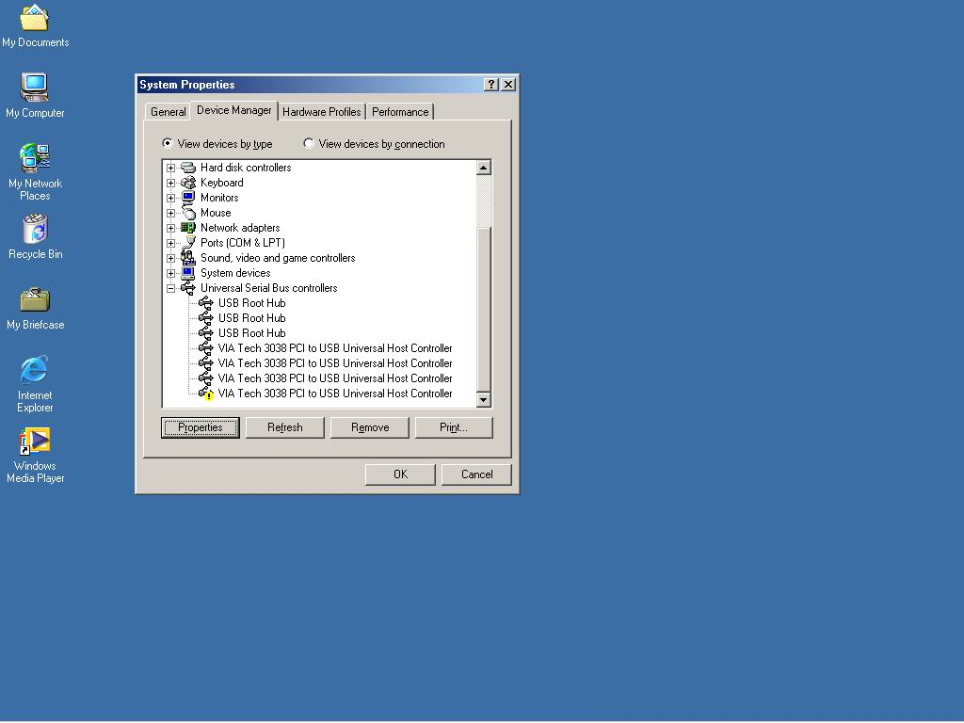
- Insert the supplied “Windows 98/ME/Win2K/WinXP USB 2.0 Driver Installation CD” and execute the setup program by double click on the “SETUP.exe” file.

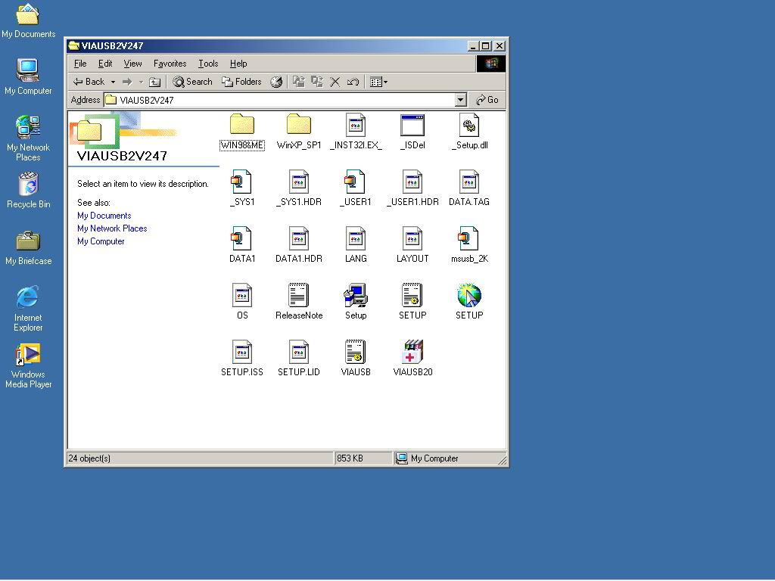
3. Press “Next”.

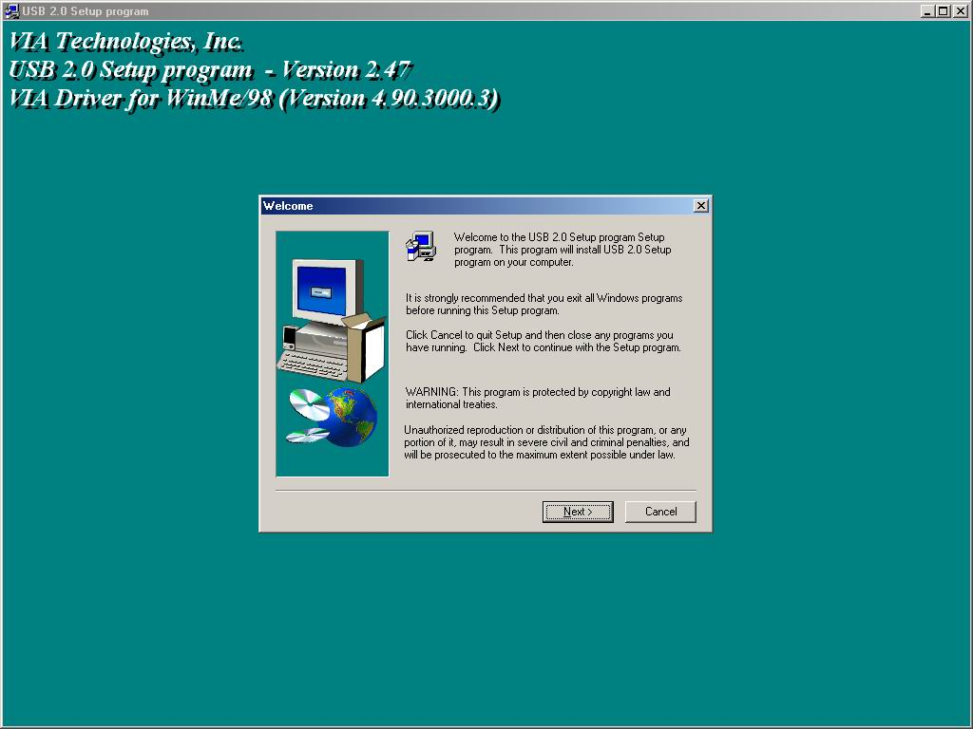
- Select “Install USB Driver” and press “Next”.

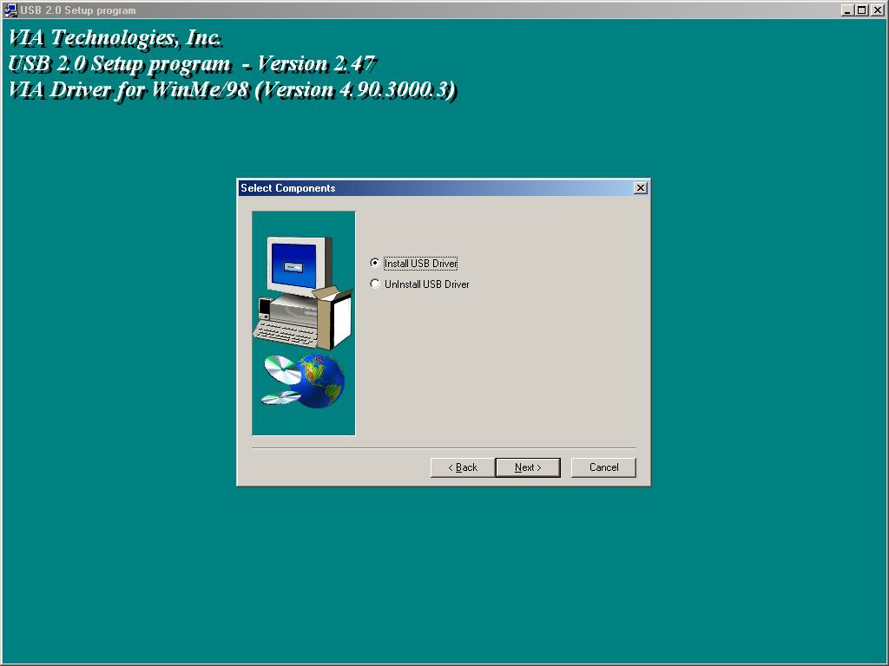
- Press “Finish” and this will RESTART the computer system. Please remember to SAVE all files before clicking the “Finish” button.

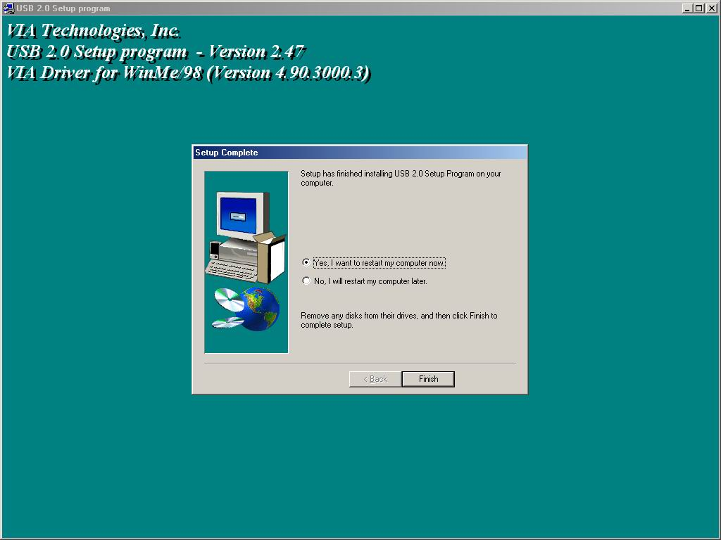

Note: For Driver Uninstallation, the user can remove the “Microsoft USB 2.0 Host Controller Driver” by selecting the “Uninstall” button. This will completely remove the driver from the system.

